Scripts User Manual

This manual is a guide to setting up and using Kaley’s scripts. The first section is dedicated to RayStation scripts, the second to all other scripts. There is both technical/implementation information aimed at scripters, as well as “how-to” usage information for any end user.

Contents

RayStation Scripts 1

How to Implement a Script in RayStation 1

Example 1

add_box_to_external 2

Example 2

copy_plan_without_changes 3

Example 3

Other Scripts 4

ChromeDefaultBrowser 4

Dependencies 4

Implementation 4

# RayStation Scripts

## How to Implement a Script in RayStation

See RaySearch's official Scripting Guidelines for comprehensive coverage of how to implement a script in RayStation, but following is CRMC’s preferred system.

RayStation scripts are stored in T:\Physics\KW\med-phys-scripts\RayStation. Each “main” script defines a function with the same name as the file. The “blurb” scripts are in the Blurbs folder. Each “blurb” script has the same name as the “main” script prepended with an underscore, and simply imports and calls the function from the “main” script. The “blurb” script is imported into RayStation. Separating the files in this way keeps us from having to invalidate, edit in RayStation or reimport from file, revalidate, and save the script every time we change the code.

We always use our custom RayStation scripting environment CPython 3.8, and we give the scripts in RayStation, more human-friendly names.

### Example

Here is how we set up Add Box to External in RayStation:

1. Write add_box_to_external.py and save it in the RayStation folder.

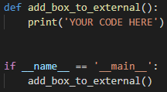

1. Write _add_box_to_external.py and save it in the Blurbs folder.

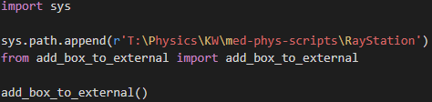

1. Import the blurb into RayStation and name the script Add Box to External.

## Add Box to External

Modifies the external (body) geometry on the current exam, to include some of the Vac-Lok™ geometry used for SBRT patients.

SBRT lung patients are positioned using a Vac-Lok™ bag. When planning, we prefer our external geometry to include the body of the patient as well as some area posterior and right/left of the patient. This area ideally encompasses the entire couch geometry in the I-S and R-L directions, and up to the localization point in the P-A direction. In practice, we crop the area by a pixel on each R-L side to prevent possible calculation errors due to the external extending outside the image.

Of course, we want to retain the original external geometry, so before adding the box to it, we copy the external geometry into a new ROI called External^NoBox.

## Example

Here is what the external looks like before running the script; it's just the body:

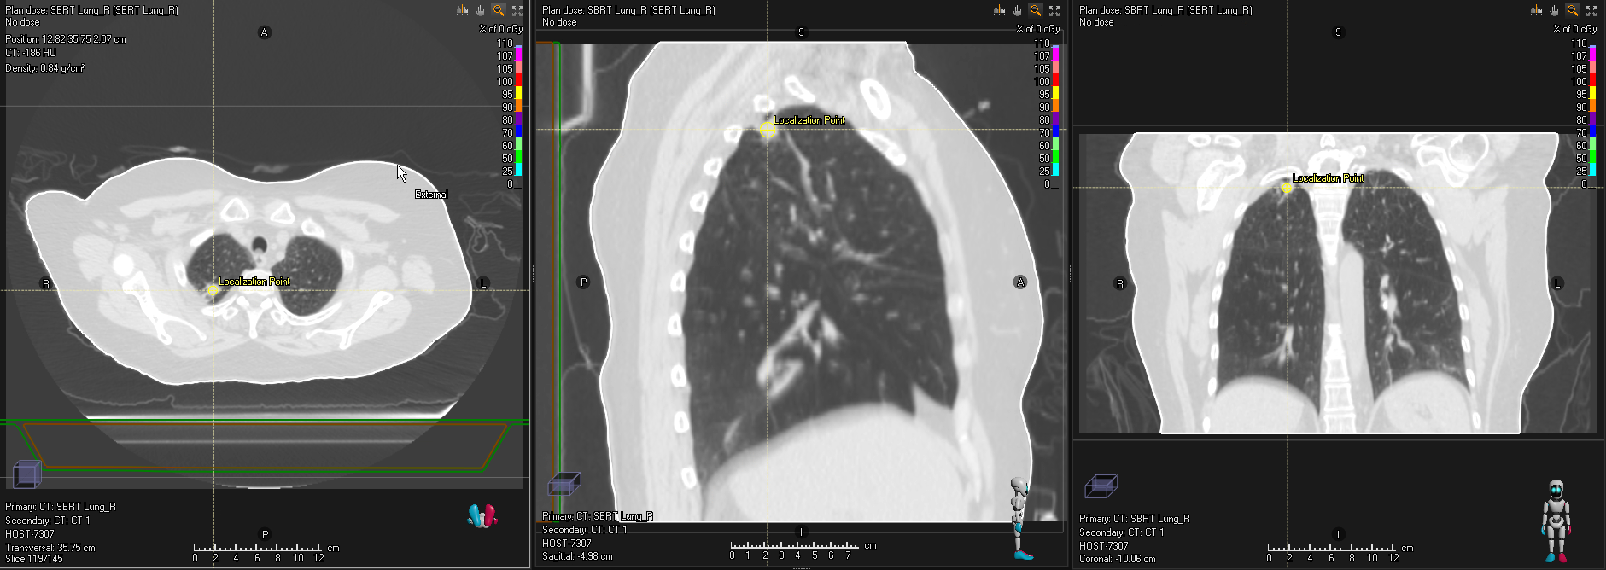

After running the script, we have the modified external:

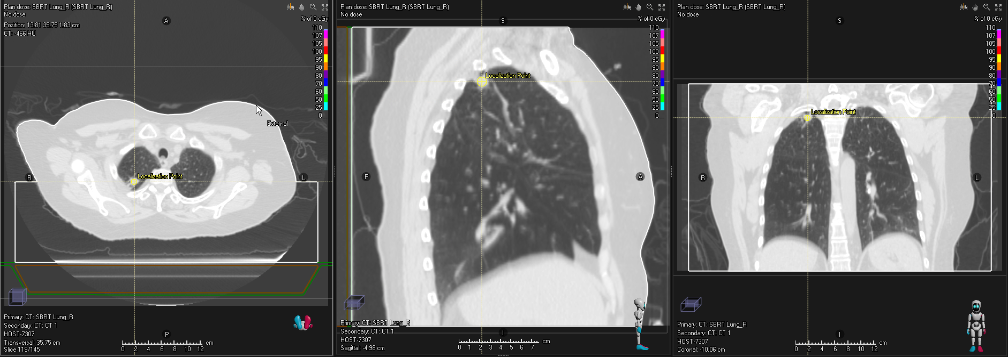

And External^NoBox, containing the original external geometry:

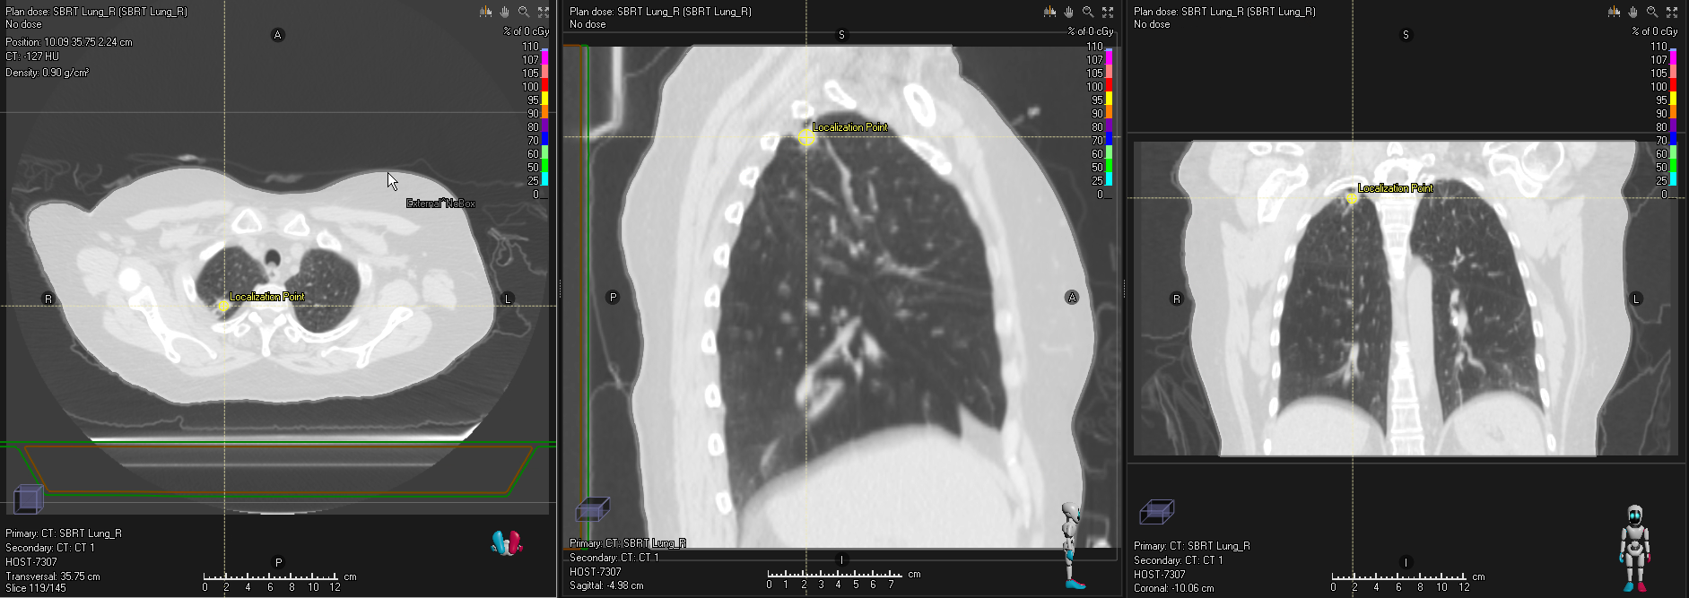

## Add Clinical Goals

Adds clinical goals templates from a spreadsheet, to the open plan.

RayStation has clinical goals templates, but they are cumbersome to update. It is easier to keep an updated spreadsheet of clinical goals for various sources/MDs, body sites, treatment techniques, Rx’s, fractionation patterns, etc. We keep this spreadsheet in T:\Physics\KW\med-phys-spreadsheets.

## Add Couch

[Documentation coming soon]

## Add Derived ROIs

[Coming soon]

## Clean Up Geometries

[Coming soon]

## Contour Chestwall

[Documentation coming soon]

## Convert Virtual Jaw to MLC

[Documentation coming soon]

## Copy Goals & Objectives

[Coming soon]

## Copy Plan to New CT or Merge Beam Sets

Copies a photon or electron plan to another exam or merges beam sets for plans on the same exam. The new exam must have an external geometry. I modified this script from one provided by RaySearch support.

The script presents two tabs:

* **Copy Plan To New CT**

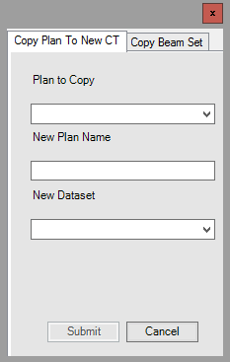

* **Copy Beam Set**

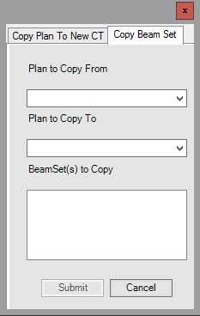

The “copying” is less comprehensive than we’d prefer, but this script is the closest that RaySearch could provide. The problem is that we can’t directly copy control points. We must first optimize. But only IMRT plans need optimization. Even for IMRT plans, since optimization is stochastic, we can’t expect to copy the old beam set’s goals, objectives and constraints, and optimization parameters to the new beam set and get the same results. Therefore, before manually copying the control points from the old beam set to the new, the script performs a dummy optimization with a dummy PTV. There is a single objective based on the beam set’s primary prescription:



Another problem is that structures are not copied to the new exam.

### Example

Here, we copy the plan SBRT RLL from the exam AVE 3-23-22 PLAN HERE to the exam AVE 3-23-22 created in RS.

The old plan:

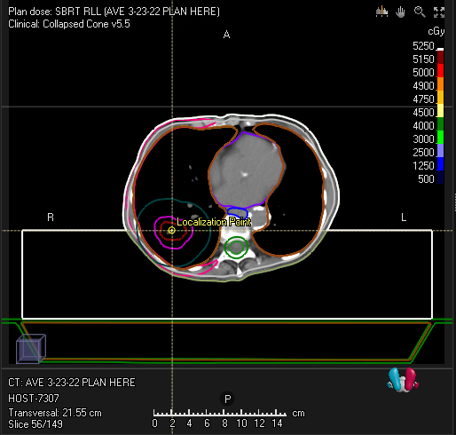

Set the appropriate values in the script:

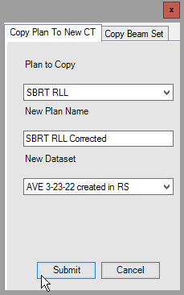

A new plan called SBRT RLL Corrected will be created on the exam AVE 3-23-22 created in RS.

## Copy Plan without Changes

Copies the current plan, retaining beam set and isocenter names.

RayStation's **Copy plan** functionality is amazing, but we wanted to change a couple of naming conventions in the copy:

* Retain beam set and isocenter names.
* The beam sets and beam isocenters in the copied plan have the same name as the plan, plus a copy number. For example, if a plan called R Breast with two beam sets is copied to a plan called R Breast (1), the new beam sets are called R Breast (1) and R Breast (1)_2 respectively, regardless of their names in R Breast. Likewise, the beam isocenters are called R Breast (1) 1 and R Breast (1).
* Renumber the new beams.

We make the new beam numbers unique among all beam numbers in the patient. The first beam is numbered one more than the greatest beam number in the patient, and beam numbers increase consecutively from there.

* Name beams the same as their numbers.

We want to retain any important information from the old name, though, so if an old beam name is different from its number (or a setup beam name is not the default), we append the old name to the new description.

The new plan name is the same as the old plan name plus a copy number (e.g., R Breast (1)).

### Example

Given a plan Plan 1:

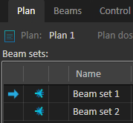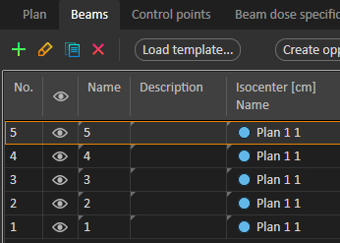

If we copy Plan 1 using the **Copy plan** button, naming the copy Plan 1 (1), we get these names and numbers:

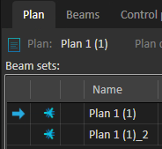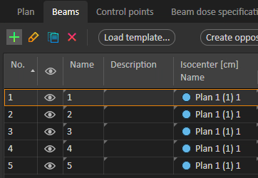

If we instead copy the plan using the script, the Plan 1 (1) beam sets and beams match those in Plan 1 and are uniquely numbered:

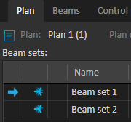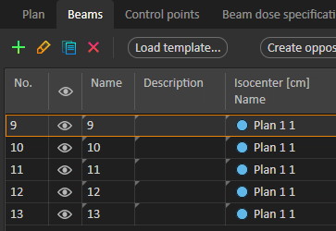

## Copy Beam Set

[Coming soon]

## Copy Exam

[Coming soon]

## Create QA Plan

[Coming soon]

## Delete Empty ROIs

[Coming soon]

## Dose Grid Box

Adds a box ROI with geometry that outlines the dose grid of the current beam set.

The dose grid outline in RayStation is (sensibly!) faint. When we want the dose grid to be more visually obvious, we outline it with a box ROI geometry.

### Example

The dose grid is faint:

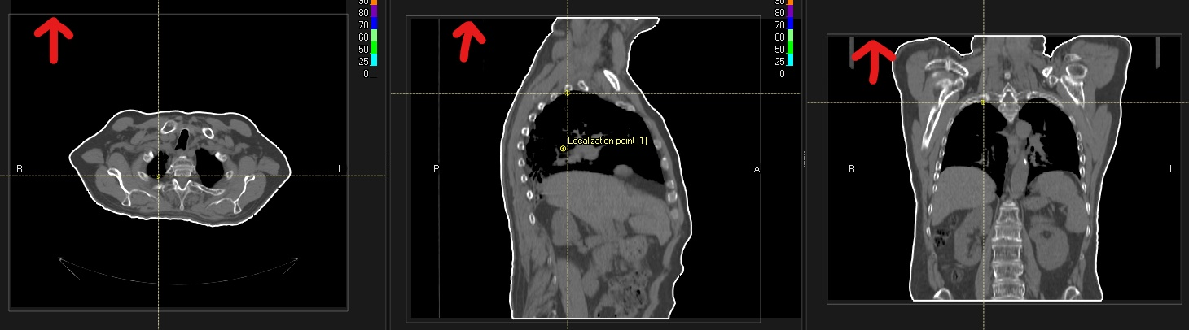

But the purple box is prominent!

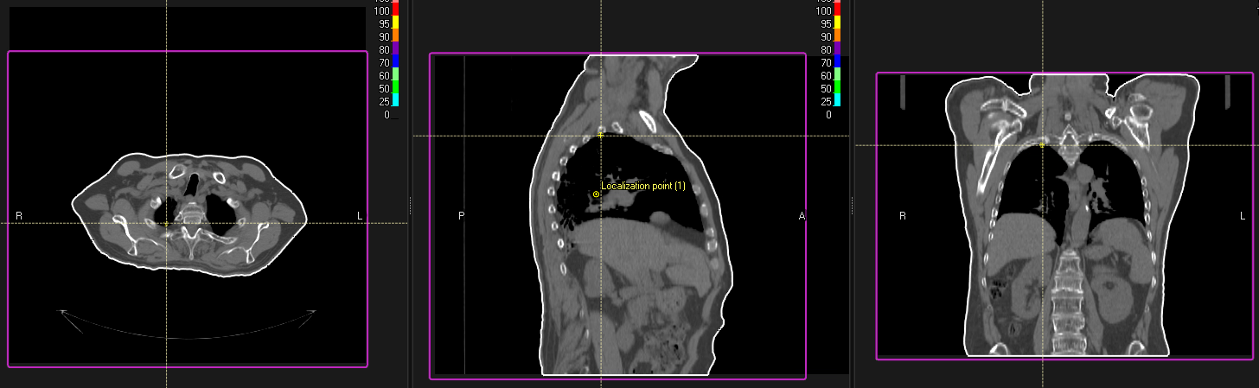

## Exclude from MOSAIQ Export

[Coming soon]

## Export DVH Curves

[Coming soon]

## Export Line Doses

[Coming soon]

## Extend Exam

[Coming soon]

## Generate Shifts Comments

[Coming soon]

## Last Modified Times

[Coming soon]

## List Patients

[Coming soon]

## Localize to Beam Iso

[Coming soon]

## Plan Check

[Coming soon]

## Prepare Exams

[Coming soon]

## Print Report

[Coming soon]

## QACT Adaptive Analysis

[Coming soon]

## TG-263 Names & CRMC Colors

[Coming soon]

## Scale Objectives & Constraints

[Coming soon]

## Show Non-Empty Geometries

[Coming soon]

## Update Clinical Goals Templates

[Coming soon]

# Other Scripts

## ChromeDefaultBrowser

We recently had an issue with our default browser. Every day when we logged in, we set Chrome as the default browser. But the next morning, the default browser was reset to Edge. It turned out that Group Policy had started resetting everyone's default browser to Edge upon logout. Therefore, in order to use a different default browser, we must manually set it every time we log in. Here is a way to automatically set Chrome as your default browser every time you log in. Like all good IT workarounds, it doesn't require admin permissions.

I got this solution from [Stack Exchange](https://superuser.com/questions/15596/automatically-run-a-script-when-i-log-on-to-windows), [Mark McClelland](https://poetengineer.postach.io/), and [Christoph Kolbicz](https://kolbi.cz/).

### Dependencies

* The browser you want to set as the default. To use the solution as is, this is Chrome.
* Christoph Kolbicz's [SetDefaultBrowser.exe](https://kolbi.cz/blog/2017/11/10/setdefaultbrowser-set-the-default-browser-per-user-on-windows-10-and-server-2016-build-1607)
* This solution was tested in Windows 10, so it is not guaranteed to work with any other operating system.

### Implementation

The batch file ChromeDefaultBrowser.bat runs SetDefaultBrowser.exe (using the absolute path) with the chrome argument:



The file ChromeDefaultBrowser.xml is an exported task from Task Scheduler. Import it into Task Scheduler. The task runs the batch file whenever:

* Your computer is unlocked
* You log in
* You connect to a user session

The following are user-/computer-specific and should be changed:

* The path to SetDefaultBrowser.exe in the batch file. I recommend using the absolute path.
* The path to the batch file in the XML file. The path is inside the <Command> tags.
* Your username in the XML file. This is between the <Author> and the <UserId> tags, where the placeholder is DOMAIN\USER.